Climate Change Analysis

By: Yutai Long

Due to various factors since the Industrial Revolution, global temperatures have surged. In this study, we will use Data Science and Machine Learning to confirm the validity of climate change, its pattern over the years, and a rough prediction of the future of global climate. This study finds that climate change is indeed present, the rise of global temperature has accelerated since the 1970s, and the trend will continue in the absence of counteracting intervention.

Data Provided By: kaggle.com

Date Published: 2015

Time Period Covered: 1750-2015

Data Size: 300,000+ entries

Theory:

Change in global temperature in the period covered by the data is significant enough to constitute a climate change. At the current rate, this trend will continue beyond 2015.

By mapping the average temperature of each country using Plotly, we see the data does accurately reflect global temperature. Countries with high latitudes such as Russia and Canada are significantly colder than those close to the equator, such as Mali (Figure 1.1). A comparison of the average temperature of each country from 4 different time periods shows that there is roughly an increase of 1.5 to 2 Celsius for the majority of the countries from pre-1800 to modern times (Figure 1.2). Approximately a third of the increase occurred in the last 50 years.

A graph showing the average land temperature shows the gradual increase of global temperature by approximately 1.6 Celsius in the past 260 years (Figure 2.1). As natural temperature variability by year is usually no more than 0.5 Celsius in the graph (note the variability of the first 50 years were much higher due to the deficiency of measuring instruments), the change on the macro level can likely be attributed as climate change.

A country representative of each geographic region is selected and analyzed side by side. The same trend is present in each one of them, of a slow increase since 1800, and a significantly faster one since 1970 (Figure 2.2).

The data are plotted to better show the correlation of time and global temperature (Figure 3.1). Possible confounding variables such as different months are investigated, and reveal similar shape as the collective data (Figure 3.2). After removing confounding variables, a clear pattern emerges (Figure 3.3). There is clearly a strong correlation (0.794) between the variables “Year” and “LandAverageTemperature”. In fact, the correlation might not be linear, but exponential, which is really bad for our planet. Following the linear trend, the world’s average temperature is expected to rise by another 1 Celsius before 2050. If the trend is exponential, the temperature will rise significantly more.

Conclusion:

Climate Change is present and accelerating in recent years, possibly due to the rise of energy consumption and an increase in the amount of fossil fuel used. It affects all continents on Earth, and each month of the year. If nothing is done to reverse this process, even by a conservative estimate, we may see global temperature rise by another 1 degree celsius by midcentury.

Appendix

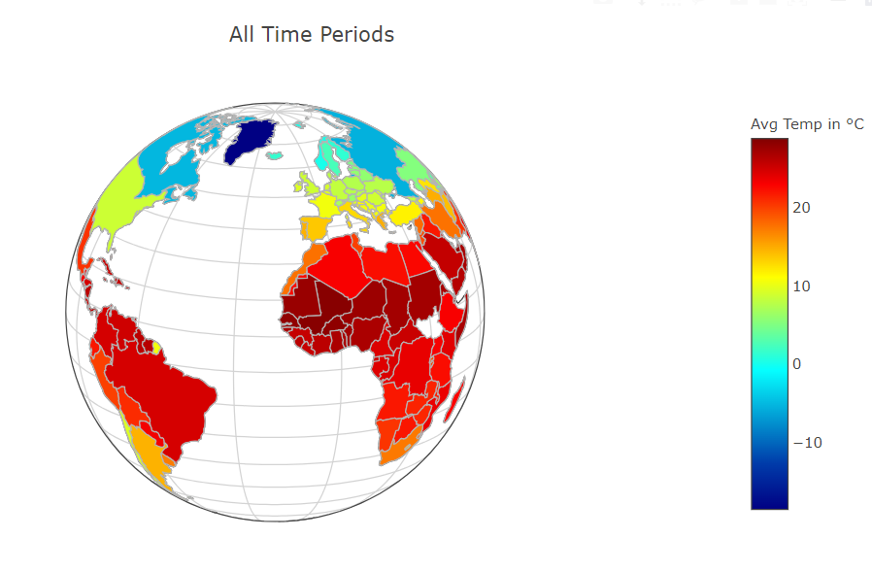

Figure 1.1

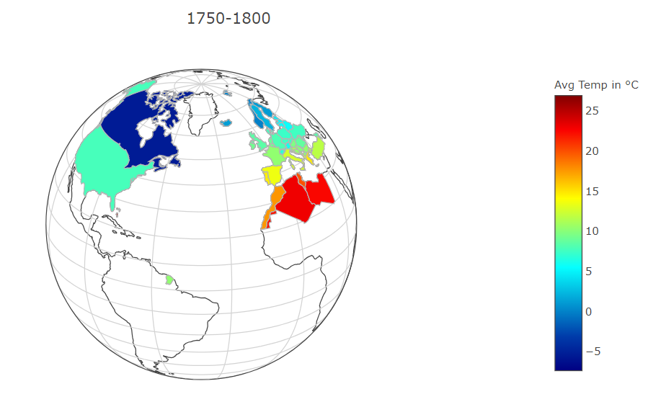

Figure 1.2.1

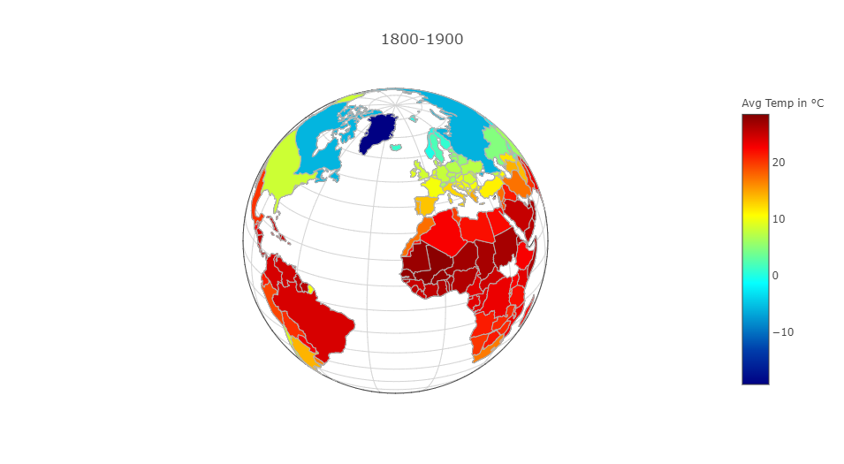

Figure 1.2.2

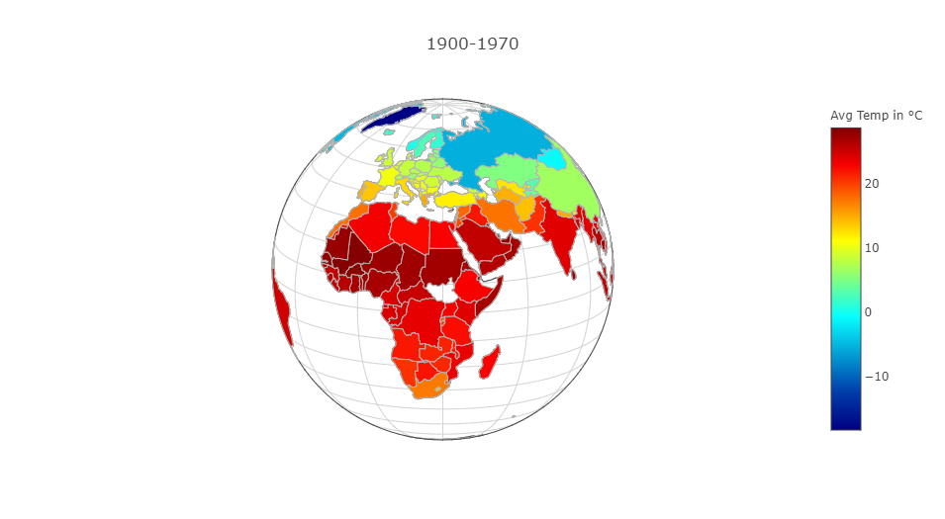

Figure 1.2.3

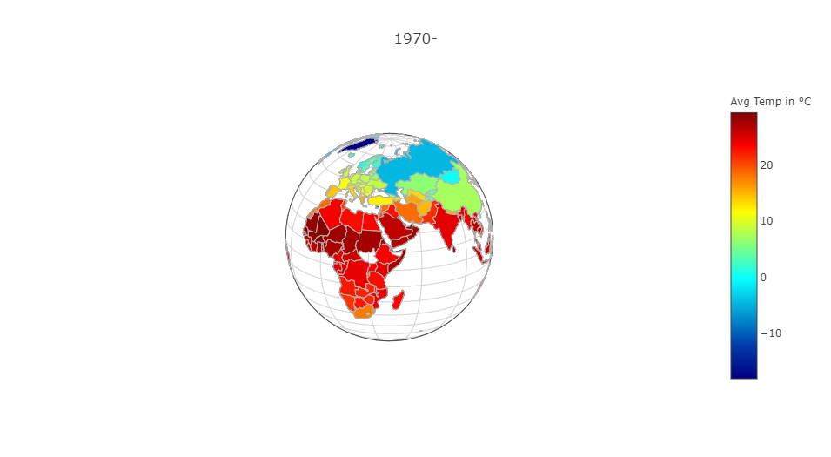

Figure 1.2.4

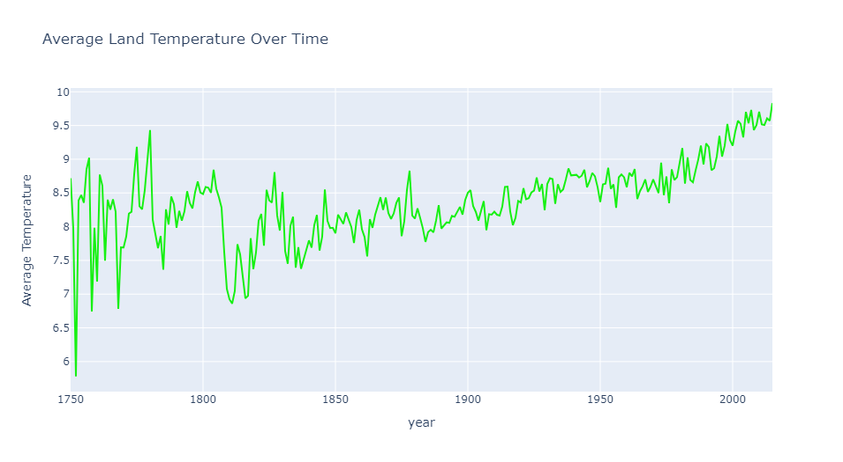

Figure 2.1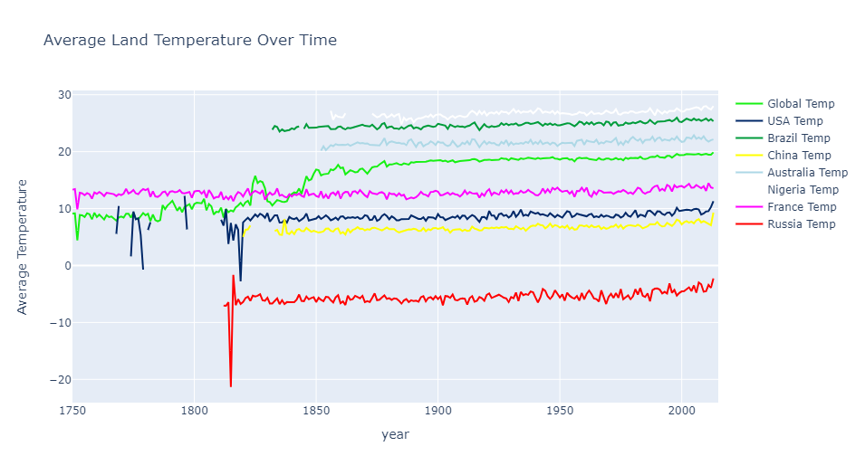

Figure 2.2

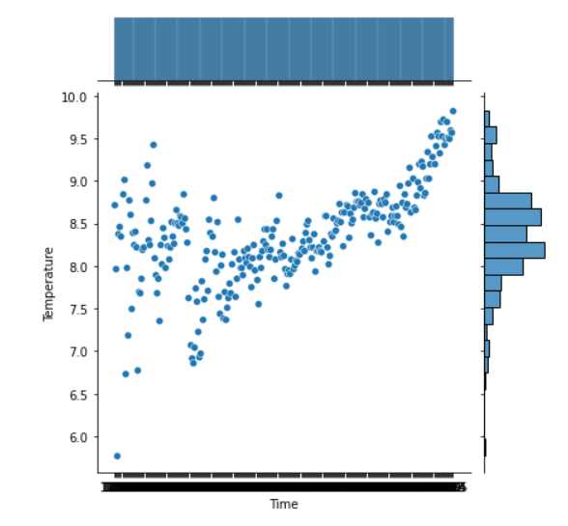

Figure 3.1

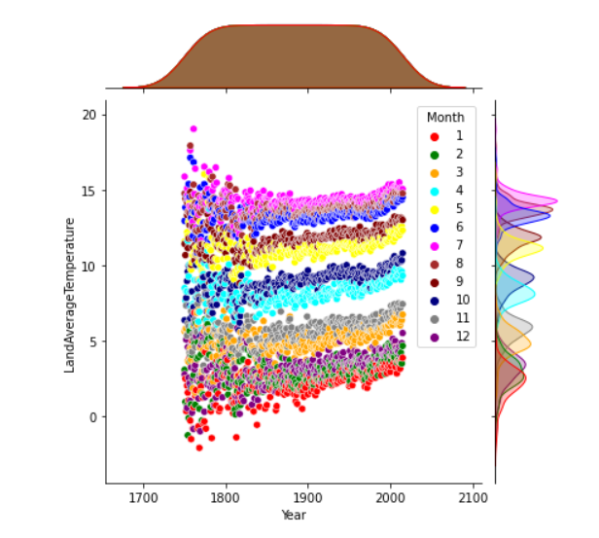

Figure 3.2

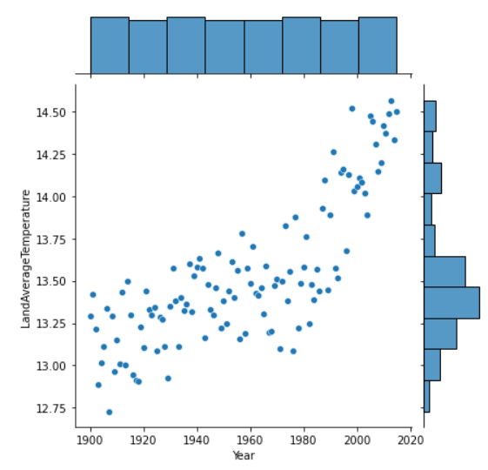

Figure 3.3

Full Code

https://github.com/Yutai007/Climate-Change-Analysis/blob/main/main.ipynb